FAQ to the Canvas help email

- How do I (a student) log into canvas?

Follow the instructions below to log into Canvas.
- Note 1: for those who used Canvas last year, ISD is no longer needed as part of the login but is required (in all caps) as part of the password.
- Note 2: Be sure not to overlook the fact that ISD (in all caps) is required at the end of the student number as part of the password
Make sure you are using the Issaquah School District login page which can be found here: https://issaquah.instructure.com/login/canvas

Your username will be the first 4 letters of your last name, the first three letters of your first name and then the last two numbers of your graduation year. Make sure you are using your LEGAL name as it is shown in Family/Student Access (Skyward).
Examples:
- John Smith who is graduates in 2021 (SmitJoh21)
- Lucy Lo-Lee who graduates in 2026 (LoleLuc26)
Your password is your 7-digit student ID number + ISD (in all capital letters).
Examples:
- 1234567ISD
- 0654321ISD
This number can be found on any of your old ASB cards, OR within Family/Student Access. Make sure you use the WHOLE number, if your student number starts with a zero be sure to include the zero.
To find your student ID in Family Access, look here:
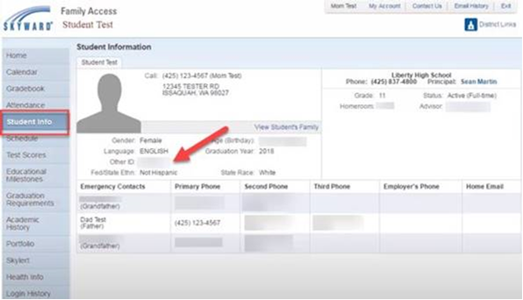

- How do I (a parent) log into canvas?
Please follow the instructions below for parent login as an observer.
Note 1. Login for Canvas is not your Skyward user ID.
Note 2. Be sure to use the email associated with you in Skyward as Skyward and Canvas are linked.
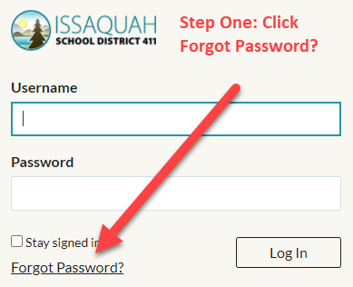

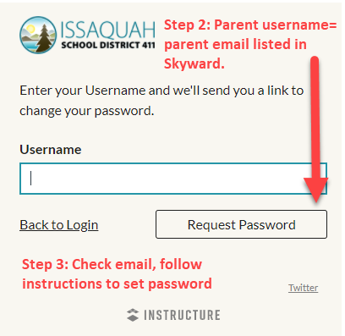

- I am a parent and now getting lots of notifications for everything my student does. How do I change my notification settings?

Managing Notifications
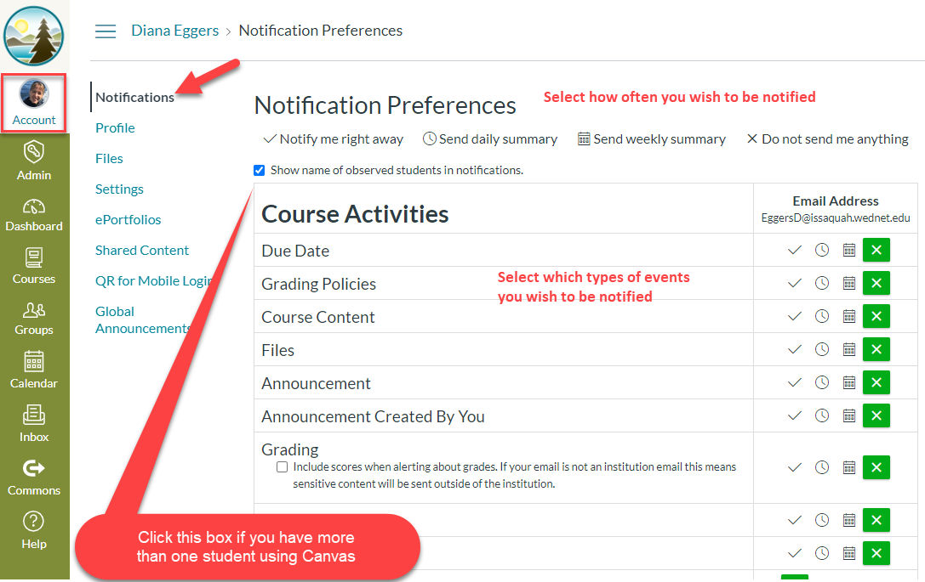

- Why can’t I see my schedule in Canvas?
Be sure to click on “Courses” on the left-hand navigation bar in canvas to see a student’s classes. The calendar and other areas may not reflect all classes.
Note: Canvas syncs to Skyward. As such, if I change was made to a schedule, it may take a day to be reflected in Canvas.

- Why am I able to log into Canvas on one device but not another?
Canvas appears to work better with some browsers vs. others. At this time, we suggest Google Chrome. Here is the technical information from Canvas. https://issaquah.instructure.com/courses/9180/pages/technical-details

- How do I log into Office365?
Login for Office365 is the student’s ISD email address and the password is their student ID number. If a student had updated their password last year, all student passwords were reset before school started to be their student ID number.

- I am not able to get into the zoom meeting my teacher posted on Canvas, what do I do?
Contact your teacher directly about the link for classes posted in Canvas. If you don’t know their email, you can find it here: https://www.issaquah.wednet.edu/directory

